

***LAB REPORT 1***

***Muhammad Rafay***

***20P-0018***

***Computer Networks***

***Sec B***

**Experiment 1: Retrieving Basic TCP/IP Network Information using ipconfig**

We can troubleshoot the computer networks issues .

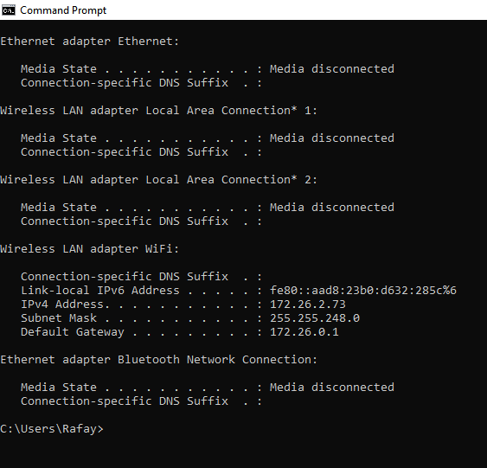

**Experiment 2: Exploring Syntax and Parameters of the ipconfig Command:**

1. Display MAC Address of Only Physical Connected Network Adapters

ipconfig /all | findstr /v 00-00-00 | findstr Physical using this command with | (Bar) is making it easy to read and find only physical connected MAC Address.

| Here is used to create a pipeline/ funnel for the process

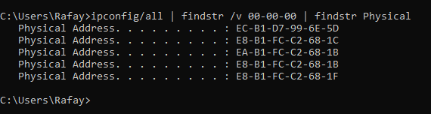

1. View DNS Cache

Command Used : ipconfig /displaydns

This command is typically is used to troubleshoot specific DNS lookup issues.

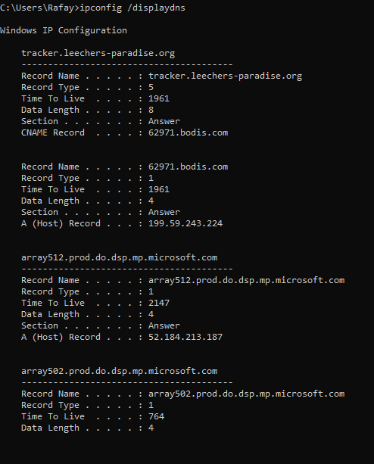

**Experiment 3**: Retrieving All TCP/IP Network Information using the ipconfig /all Command and redirect it to a text file.

C:\Users\Rafay>ipconfig /all >F:\ipconfig-results.txt

This will create a file named ipconfig-results.txt in the folder path . File will have your result for

Ipconfig /all you can open the file with any text editor to read/see the results.